**Issues Faced during Task:**

* For Testcase number 2, could not automate it because no options are displayed as mentioned in the steps in the file I received via Email, and I attached a screenshot to make things clear.

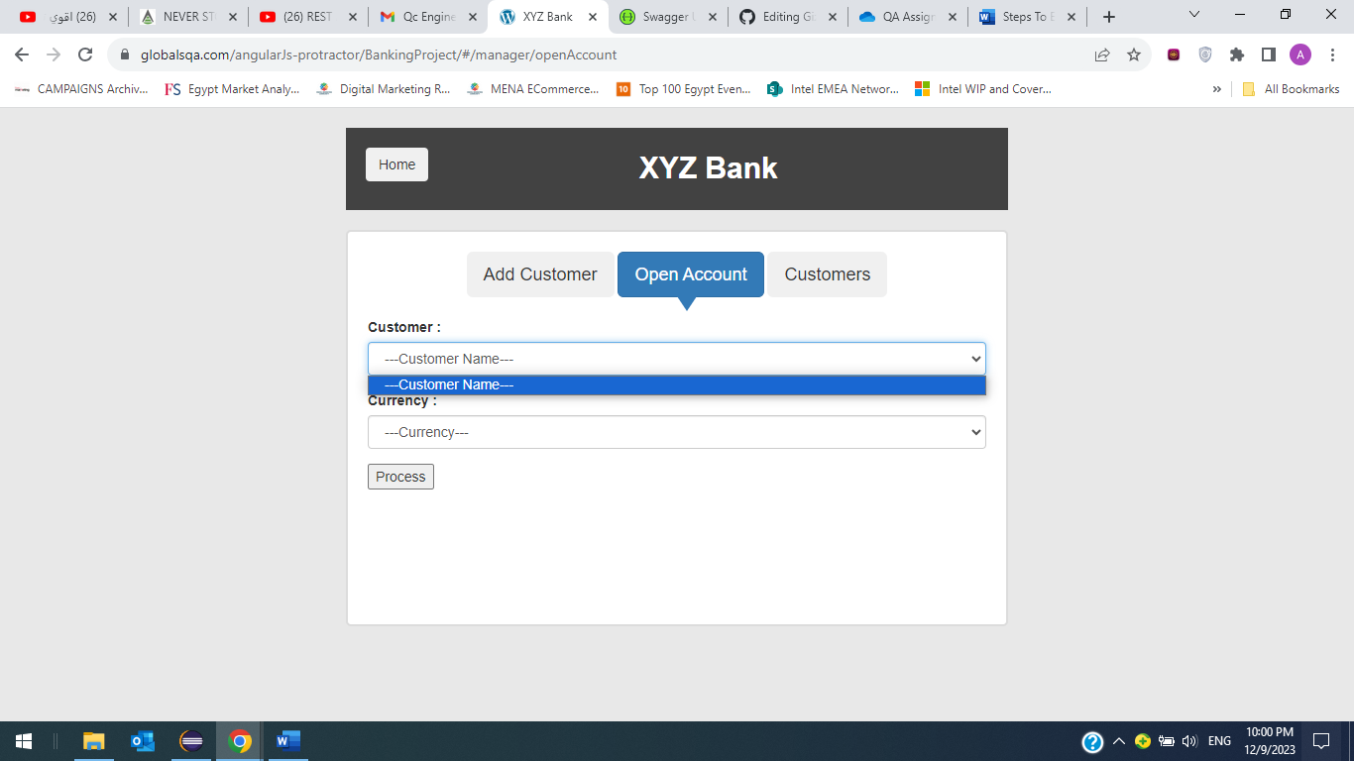

* For Testcase 6) I could not automate it as well because no options are displayed as mentioned in the steps in the file I received through email and I took a screenshot to show what I get when I click on “Customer Login” button

